DA 6823

Vishwa Koppisetti

Module 2: Part #2 (55 points)

**Standard Error of the Estimate + Confidence Intervals + the Logic of Hypothesis Testing + Type 1 and Type II errors**

**General Instructions:** In your own words, answer each of the following questions - don’t copy (e.g. cut and paste) some definition out of a book word for word. This is not a group project – you are expected to complete this module on your own. You may refer to text books, online or other sources but not your fellow classmates. If you don’t understand the question, feel free to ask the instructor in class, in office hours or in an email.

1. Explain in your own words what a type I error is (4 points)

Type I error is false positive result. It is the rejection of a null hypothesis when we should have retained it. That means we believe we found a genuine effect (i.e., Ho is false) when in reality there isn’t one (i.e., Ho is true).

For Example, null hypothesis, Ho: The person is healthy, alternative hypothesis, Ha: The person is not healthy. If the test results say that the person is not healthy even though in reality, he/she is healthy then we made a type I error.

1. Explain in your own words what a type II error is (4 points)

Type II error occurs when the null hypothesis is false but erroneously fails to be rejected. It is a false negative result. This means that we found there is no genuine effect (Ho is true) when in reality there is one (Ho is false).

For example, Ho: The person has cancer, Ha: The person doesn’t have cancer. If the test result says that

The person has cancer when in reality he doesn’t, since we accepted Ho and concluded he has cancer then we made a type II error.

1. Imagine that you are a cancer researcher who has developed a new test for cancer. Think about what a type I and type II error means for this kind of test. Argue for what you think is the most egregious error – a type I or type II error in this case. (Hint – you can logically argue for either case, just explain why). (6 points)

If we define Ho: the patient has cancer, Ha: the person doesn’t have cancer,

**Type I error** occurs when in reality the person has cancer, but the test results show the person doesn’t have cancer.

**Type II error** occurs when in reality the person doesn’t have cancer but the test results show that he has cancer.

**Both errors could be fatal.**

**Type I error consequence:** If a person is wrongly diagnosed as not having cancer then he may not be treated with the required medicine. This may lead to his death which could be avoided or delayed with the right diagnosis and medicine.

**Type II error consequence:** If a person is wrongly diagnosed as having cancer when he actually doesn’t have cancer then he may be given wrong and unnecessary medication which could lead to new problems and deteriorate his healthy life for no reason at all. Not to mention the trauma that he and his family may have to go through when there is actually no real disease.

But if we have to pick the **most egregious error** in this scenario, it would be **type I error** since the person may lose his life which could be saved with proper diagnosis and treatment.

1. Explain in your own words what the power of a statistical test means (4 points)

Power of a statistical test is the probability of making a correct decision of rejecting the null hypothesis when in fact it is false. It is the probability that a test of significance will pick up on an effect that is present.

We are typically interested in the power of the test when the null hypothesis

Is in fact false. This definition makes it clear that power is conditional probability. It is the probability of avoiding a type II error.

1. Name two things that can affect the power of a statistical test (4 points)

Two things that can affect the power of a statistical test:

Sample size n: As n increases the power of the statistical test increases.

The significance level **α** of the test: All other factors constant as α increases so does the power of the test

1. Here are the six steps of hypothesis testing:
   * 1. State the null (Hnull) and alternative (Halt) hypotheses
     2. State the assumptions of the test
     3. Determine the critical value for the test statistic
     4. Calculate the value of the test statistic from the data
     5. Compare the calculated and critical values for the test statistic
     6. Apply the decision rule and interpret the result of the test

We will use a simple chi-square test as our example in this module. Here is the data that examines if there is a relationship between gender and format of book read:

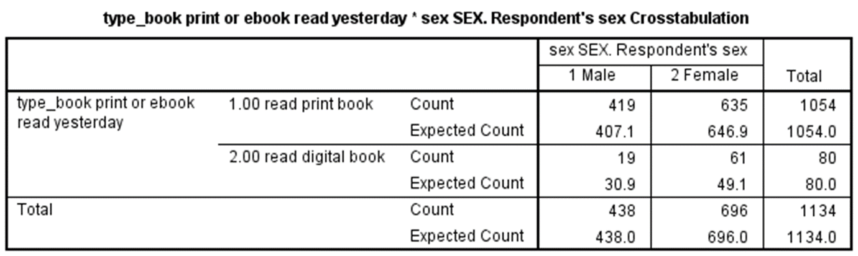

The questions on the next page take you through each step applying the chi-square test to this data. Use a stats book and/or the Internet to help you with this but write your answers in your own words, not copy and paste.

1. State the null and alternative hypotheses for this test. (4 points)

Null Hypothesis Ho: There is no relationship between the gender and format of the book read, they are independent.

Alternative Hypothesis Ha: There is a relationship between the gender and format of the book read, they are not independent.

1. State at least one assumption for this test. (3 points)
2. The variables under study should be categorical. Here both gender and format of book read are categorical
3. The sample method is simple random sampling
4. If sample data are displayed in a contingency table, the expected frequency count for each cell of the table is at least 5.
5. Determine the critical value of chi-square that your data will have to exceed in order to reject the null hypothesis. This involves calculating the degrees of freedom for our data as well as looking up the critical value in a chi-square table. Show your work for calculation degrees of freedom. (6 points)

Degrees of Freedom, DF = (r - 1) * (c - 1)

where r is the number of levels for one categorical variable (Gender), and c is the number of levels for the other categorical variable (Format of Book read)

DF = (2-1) * (2-1) = 1

We choose a significance level of 0.05, search for its critical value in a chi-square with the help of DF=1. We find it to be 3.841. This means the data will have to exceed this critical value of 3.841 to reject the null hypothesis.

1. Write out the chi-square formula and then using the data in the table provided above, calculate the chi-square value from the data. Show your work. (10 points)

Chi-Square formula, Χ2 = Σ [ (Or,c - Er,c)2 / Er,c ]

Er,c = (nr * nc) / n. They would be r*c = 4 expected frequencies

Er,c is the expected frequency count for level *r* of Gender and level *c* of book format,

nr is the total number of sample observations at level r of Gender,

nc is the total number of sample observations at level *c* of format read,

n is the total sample size



Em,p = 438*1054/1134 = 407.10 ( also given in the table)

Om,p = 419

Em,d = 438*80/1134 = 30.90 ( also given in the table)

Om,d = 19

Ef,p = 696*1054/1134 = 646.90 ( also given in the table)

Of,p = 635

Ef,d = 696*80/1134 = 49.10 ( also given in the table)

Of,d = 61

Χ2 = (419- 407.1)2/407.1 + (19-30.9)2/30.9 + (635-646.9)2/646.9  
    + (61-49.1)2/49.1

Χ2 = 0.3479 + 4.5828 + 0.2189 + 2.884 = 8.0337

Therefore, Chi-square value **Χ2 = 8.0337**

1. Compare the chi-square critical value and the chi-square value calculated from the data and draw a rough sketch of a chi square curve and place those two values on the curve. (5 points)

From 6(c), we found Chi-square value to be 3.841. Chi-Square value obtained from the data is 8.0337 which is to the right of 3.841. We can expect a much smaller percentage that exceeds 5% and reject the null hypothesis.

From the Chi-square table the p-value is 0.005.

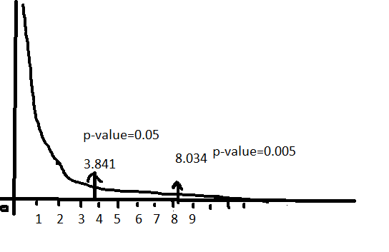

1. Apply the decision rule for the chi-square test and interpret the result of your analysis. (5 points)

Since the p-value for chi-square value 8.034 is 0.005 which is lower than p-value 0.05 of critical value 3.841 and significant at p-value < 0.05, we can reject the null hypothesis and conclude that there is a statistically significant relationship between gender and format of book read. They are not independent